*(8) Describe about Implementation, Post Implementation & maintenance, briefly.*

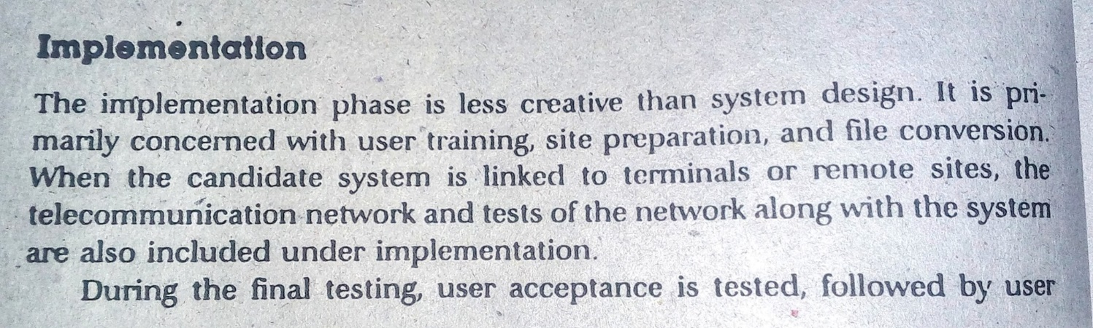

Page 46

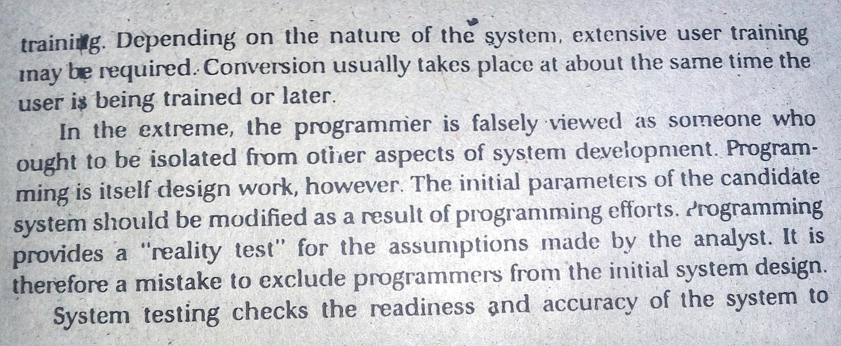

Page 47

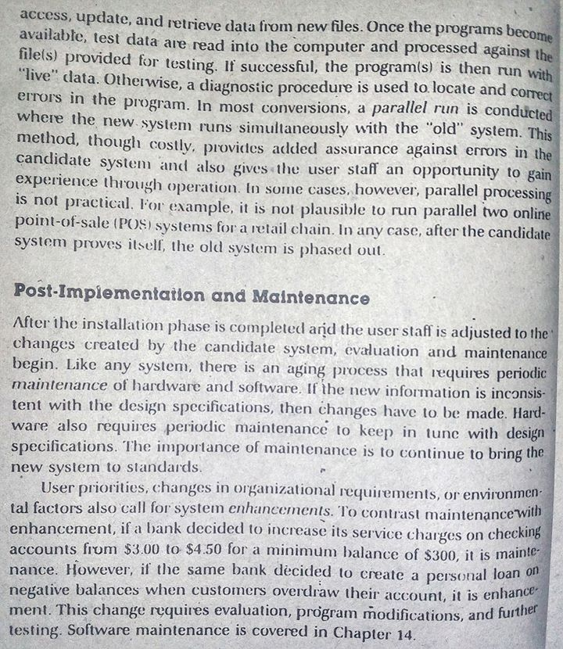

Page 48